EBIT Run June 13-16, 2017

Written by: Samuel Sanders and Roshani Silwal

MOTIVATION AND GOALS

1. High Z elements are of significant interest, both theoretically and experimentally, given their sensitivity to relativistic and QED effects. We are interested in the measurement of transitions of ytterbium N-shell ions (Ni-like through K-like) and the M-shell (Na-like through Ar-like) in continuation of the measurement in May and November for Rb-like through Ni-like ions. With this measurement, we continue to provide critical spectroscopic data for different research communities. The measurement was performed in the extreme ultraviolet (EUV) region using a flat-field grazing incidence EUV spectrometer with a liquid nitrogen cooled CCD.
2. With the installment of the vertical x ray crystal spectrometer to the recently open EBIT output port in addition to the horizontal x ray crystal spectrometer at NIST, we intend to measure polarization of the He-like Ar w (resonance), x and y (intercombination), and z (forbidden) transitions. These spectrometers have polarization selective energy dispersion and with one detector placed parallel to the electron beam and the other placed perpendicular, measurement of the polarization effects become straight forward. Furthermore, the non-Maxwellian collisional radiative code (NOMAD) developed to simulate the EBIT plasma and to understand the atomic processes inside the trap isn’t able to calculate the effect of polarization in our measurements in the x ray region yet. With the availability of experimental results, our theoreticians believe to improve their models by adding polarization to match the measurements better.

EXPERIMENTAL SETUP

Three instruments were used to collect data during the run. The measured spectral regions include EUV and x-ray.

*EUV Spectrometer:*

For most part of the data run, EUV spectra were collected for Yb. The primary measurements of interest lie in the EUV region as a continuation of the run in May 2017 and November 2016. Details on the EUV CCD are listed in Table 1.

Table 1: EUV CCD Details

|  |  |  |  |  |  |
| --- | --- | --- | --- | --- | --- |
| **Instrument** | **Pixel array size** | **Pixel Size (µm)** | **Software** | **Operation Temperature** | **Readout Rate** |
| Princeton Instruments CCD | 2048 x 512 | 13 | Winspec | -120 °C | 100 kHz |

For the entire run, the EUV CCD temperature was locked at −120 °C, the readout rate was 100 kHz to provide the lowest readout noise, and the controller gain was set to 3 in order to measure low-level intensity signals and reduce noise. The spectral images (2048×512 pixels), registered with the help of the CCD, were integrated along the y-axis, so that the resulting image is 1D-image 2048×1 pixel. The pressure readings for the ion-pump, grating chamber and cathode gauge of mirror and grating chamber for the EUV mirror are listed in Table *2*.

Table 2: EUV Pressure Settings

|  |  |
| --- | --- |
| Mirror Chamber Cathode (Torr) | 4.80E-09 |
| Grating Chamber Cathode (Torr) | 1.30E-08 |
| Mirror Chamber (Torr) | 3.80E-09 |
| Grating Chamber (Torr) | 1.70E-08 |

In order to prevent the stray light from pumps and gauges to reach the CCD chip, the ion pump for the grating chamber and the cold cathode gauges for both mirror and grating chambers were turned off during the EBIT operation. The ion pump for the mirror chamber was operated all the time with typical pressure reading of around 3.8× 10−9 Torr during EBIT runs. The EUV vacuum is separated from the EBIT vacuum by a black gate valve which is closed at all times except during data acquisition. There is another gate valve between the mirror UHV chamber and grating UHV chamber which is open throughout the measurements.

The table below lists the range of EUV wavelengths at different positions.

Table 3: EUV Spectral Range At Given Position

|  |  |
| --- | --- |
| **Position** | **Range (nm)** |
| 0.144” (+) | 2.7 - 13.3 |
| 0.994” (-) | 4 - 19.9 |
| 0.675” (-) | 7.8 - 25.8 |

*Crystal Spectrometer*:

The Johann-type crystal spectrometer has a resolution better than 2 eV at 3 keV. The spectrometer vacuum is separated from the EBIT vacuum by a 230 μm thick Beryllium window. Currently there is a **Si(111)** crystal installed in the spectrometer is which has a 2d spacing of 6.271 and covers a spectral range of 2.219 to 4.592 keV, as shown in the image below.

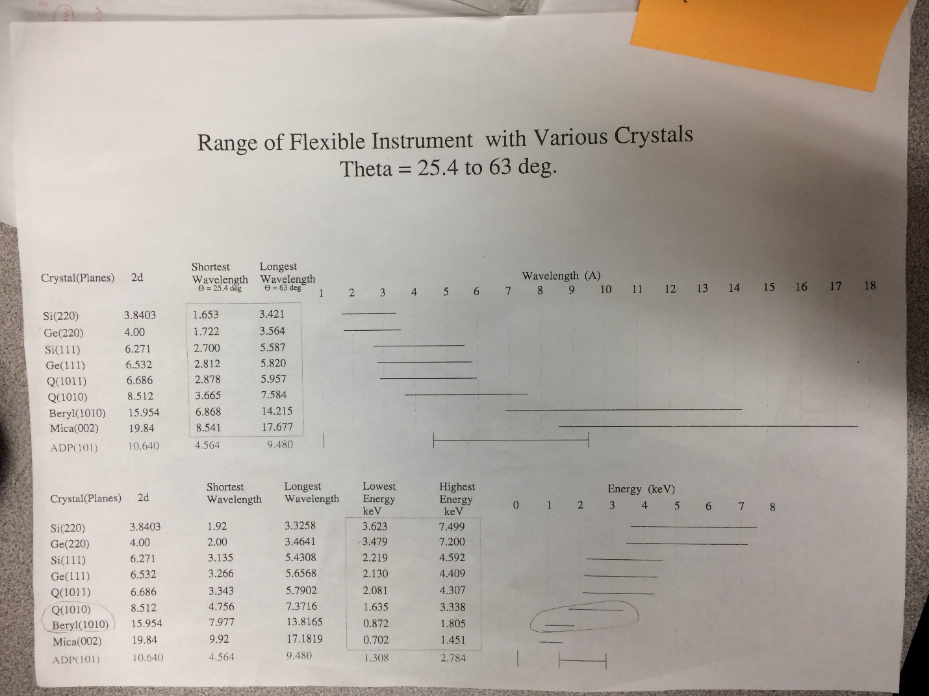

Details of the x-ray CCD used to take measurements are provided in Table 4 . The CCD was cooled to -75 °C with a chilled water setup, the readout rate was 50 KHz with a 4x amplification, and the image was saved in .sif and .fits format. The camera was kept at vacuum of 4.2 x 10-7 torr and the data was collected using the single data acquisition mode. During the data acquisition, the gauge was turned off to enhance the signal to noise ratio. The hardware temperature is maintained by the camera software ANDOR Solis.

In addition to the existing crystal spectrometer with horizontal alignment, crystal spectrometer with vertical alignment and another Si(111) crystal was added to the open EBIT output port. The EBIT vacuum and the spectrometer vacuum is separated by a 230 μm thick Beryllium window. The section in between the Be window and the main gate valve to the EBIT port is pumped by a roughing valve that shares the pumping of the crystal spectrometer in the order of 10-7 torr. This section had to be pumped throughout the measurement due to a small leak detected in the roughing valve. The valve is to be replaced by an all-metal valve after the measurement is over. It has been noted that the addition of this spectrometer to EBIT has enhanced the amount of Ar and O impurities in the EBIT signal. This might be due to insufficient pumping time on the newly added sections as well as the leak on the roughing valve. The CCD settings for the camera on the vertical spectrometer is exactly same except the type of cooling. The camera is cooled by a recirculating liquid instead of water chiller which limited the detector temperature to -70 °C instead of -75 °C.

Table 4:

|  |  |  |  |  |  |  |
| --- | --- | --- | --- | --- | --- | --- |
| **Instrument** | **Pixel Array Size** | **Pixel Size (µm)** | **Software** | **Operation Temperature** | **Readout Rate** | **Spectrometer Pressure** |
| Andor ikon-L CCD | 2048 x 2048 | 13.5 | Andor Solis | -75°C | 50 kHz | 4.2E-07  Torr |

*Germanium Detector*:

A Canberra LN2 cooled Ge-detector was used in addition to the Crystal Spectrometer to take x-ray measurements. . The HPGe detector was separated from the EBIT through a 340 nm thick aluminum-coated polymer window. Pro-X software was used to control the detector.

Note: The signal in the lower energy region (less than 2 keV) was cut-off by the software. We’re still unable to understand what is causing it.

*MEVVA [2]*:

Metal vapor vacuum arc (MEVVA) is a high current ion source containing eight different cathodes used to produce beams of metal ions for injection into the trap region of the EBIT. The cathodes are individually selectable with the control electronics and do not require moving components in vacuum. The sequence for ion production starts with an optical pulse that is received by the trigger generator. The generator then triggers the pressurized spark gap switch. This switch rapidly conducts the charge through a damping resistor and a 10m RG-8 coaxial cable, used as a high voltage cable, forming a high voltage pulse that arrives at the radio frequency (rf) tight enclosure at the MeVVA head assembly. This assembly has two sections, an upper stage, which is the rf-tight RG-8 cable interface, and a lower section which houses the high voltage vacuum feed-through flange. When the high voltage pulse reaches the tip of the cathode sample material in vacuum, it jumps a small gap to the anode which allows the arc discharge to occur. Both the cathode and anode grids are floated up to an applied bias voltage (20 kV in this case) relative to the extractor grid which remains at chamber ground. Hence ions are extracted from the arc plasma and accelerated toward the EBIT system with a kinetic energy established by the bias voltage. The cathodes are selected manually in the MEVVA control box situated in the high voltage room. The total number of MEVVA shots was recorded during the end of every run and number of shots for each cathode was recorded before switching to other cathode. Before every run, the number of shots for the cathode was reset to zero. The electron beam current was always optimized for the chosen energy.

We have used cathode H (Yb) for this measurement.

MEVVA Cathodes: A - W; B - Bi, C - Mo; D - Y; E - Zr; F - Fe; G - Nb; H – Yb

EBIT:

The EBIT parameters recorded in Table 5 were taken in the morning of the first day of measurements (6/13/17).

Table 5:

|  |  |
| --- | --- |
| Beam line Pressure (Torr) | 2.00E-09 |
| e- gun pressure (Torr) | 4.60E-10 |
| crystal spectrometer (Torr) |  |
| Mevva section (Torr) | 2.00E-08 |
| Big 3 (Torr) | 2.10E-09 |
| Bender #1 (Torr) | 5.30E-08 |
| Bender #2 (Torr) | 5.50E-09 |
| Mirror Chamber; Cathode (Torr) | 8.50E-09 |
| Grating Chamber; Cathode (Torr) | 4.40E-08 |
| Mirror Chamber (Torr) | 6.10E-09 |
| Grating Chamber (Torr) | 1.40E-08 |
| Gas injection pressure (Torr) | 3.00E-05 |
| Super Magnet resistance (Ohm) | 0 |
|  |  |
| Focus (v) | 15 |
| suppressor (v) | 640 |
| einzel lens (v) | 1500 |
| extractor (v) | -3680 |
| Transition (v) | 5 |
| filament (v) | 6.3 |
| filament (amp) | 0.495 |
| TC1 (collector exhaust) °F | 315 |
| UDT (v) | 500 |
| LDT (v) | 260 |
| MDT (v) | 400 while dumping, 0 for trap |
| Collector magnet voltage (V) | 4.8 |
| collector magnet current (A) | 0.5012 |
| SC magnet current (A) | 147.8 |
| Bucking coil voltage (v) | 0.54217 |
| snout (μA) | 19 |
| collector voltage (2kV) | 2 |

EBIT Run Day 1 (06/13/17):

Following the cool down of EBIT with liquid helium, the SCM magnet was ramped up to 147.8 A. Yb (cathode-H) was chosen for MEVVA injection.

The EUV CCD position was fixed at the micrometer reading of 0.675” such that the wavelength region is around 7.5 to 26 nm.

|  |  |  |  |  |  |  |  |  |
| --- | --- | --- | --- | --- | --- | --- | --- | --- |
| At. Num. | Sp.  Name. | Ion  Charge | El.  name | Isoel.  Seq. | Ground  Shells a | Ground  Level | Ionized  Level | Ionization  Energy (eV) |
| 70 | Yb XLIII | +42 | Ytterbium | Ni | [Ar]3*d*10 | 1S0 | 3*d*9 2D5/2 | [(](javascript:void(toggleBalloon('T')))3 443(4)[)](javascript:void(toggleBalloon('T'))) |
| 70 | Yb XLIV | +43 | Ytterbium | Co | [Ar]3*d*9 | 2D5/2 | 3*d*8 3F4 | [(](javascript:void(toggleBalloon('T')))3 555(4)[)](javascript:void(toggleBalloon('T'))) |
| 70 | Yb XLV | +44 | Ytterbium | Fe | [Ar]3*d*8 | 3F4 | 3*d*7 4F9/2 | [(](javascript:void(toggleBalloon('T')))3 677(4)[)](javascript:void(toggleBalloon('T'))) |
| 70 | Yb XLVI | +45 | Ytterbium | Mn | [Ar]3*d*7 | 4F9/2 | 3*d*6 4 | [(](javascript:void(toggleBalloon('T')))3 805(4)[)](javascript:void(toggleBalloon('T'))) |
| 70 | Yb XLVII | +46 | Ytterbium | Cr | [Ar]3*d*6 | 4 | 3*d*5 5/2 | [(](javascript:void(toggleBalloon('T')))3 929(4)[)](javascript:void(toggleBalloon('T'))) |
| 70 | Yb XLVIII | +47 | Ytterbium | V | [Ar]3*d*5 | 5/2 | 3*d*4 5D0 | [(](javascript:void(toggleBalloon('T')))4 051(4)[)](javascript:void(toggleBalloon('T'))) |
| 70 | Yb XLIX | +48 | Ytterbium | Ti | [Ar]3*d*4 | 5D0 | 3*d*3 4F3/2 | [(](javascript:void(toggleBalloon('T')))4 238(4)[)](javascript:void(toggleBalloon('T'))) |
| 70 | Yb L | +49 | Ytterbium | Sc | [Ar]3*d*3 | 4F3/2 | 3*d*2 3F2 | [(](javascript:void(toggleBalloon('T')))4 364(4)[)](javascript:void(toggleBalloon('T'))) |
| 70 | Yb LI | +50 | Ytterbium | Ca | [Ar]3*d*2 | 3F2 | 3*d* 2D3/2 | [(](javascript:void(toggleBalloon('T')))4 502(4)[)](javascript:void(toggleBalloon('T'))) |
| 70 | Yb LII | +51 | Ytterbium | K | [Ar]3*d* | 2D3/2 | 3*p*6 1S0 | [(](javascript:void(toggleBalloon('T')))4 630(4)[)](javascript:void(toggleBalloon('T'))) |
| 70 | Yb LIII | +52 | Ytterbium | Ar | [Ne]3*s*23*p*6 | 1S0 | 3*p*5 2P°3/2 | [(](javascript:void(toggleBalloon('T')))4 988(4)[)](javascript:void(toggleBalloon('T'))) |
| 70 | Yb LIV | +53 | Ytterbium | Cl | [Ne]3*s*23*p*5 | 2P°3/2 | 3*p*4 3P2 | [(](javascript:void(toggleBalloon('T')))5 101(5)[)](javascript:void(toggleBalloon('T'))) |
| 70 | Yb LV | +54 | Ytterbium | S | [Ne]3*s*23*p*4 | 3P2 | 3*p*3 2P°3/2 | [(](javascript:void(toggleBalloon('T')))5 224(5)[)](javascript:void(toggleBalloon('T'))) |
| 70 | Yb LVI | +55 | Ytterbium | P | [Ne]3*s*23*p*3 | 2P°3/2 | 3*p*2 3P0 | [(](javascript:void(toggleBalloon('T')))5 339(5)[)](javascript:void(toggleBalloon('T'))) |
| 70 | Yb LVII | +56 | Ytterbium | Si | [Ne]3*s*23*p*2 | 3P0 | 3*p* 2P°1/2 | [(](javascript:void(toggleBalloon('T')))5 731(5)[)](javascript:void(toggleBalloon('T'))) |
| 70 | Yb LVIII | +57 | Ytterbium | Al | [Ne]3*s*23*p* | 2P°1/2 | 3*s*2 1S0 | [(](javascript:void(toggleBalloon('T')))5 860(6)[)](javascript:void(toggleBalloon('T'))) |
| 70 | Yb LIX | +58 | Ytterbium | Mg | [Ne]3*s*2 | 1S0 | 3*s* 2S1/2 | [(](javascript:void(toggleBalloon('T')))6 111(6)[)](javascript:void(toggleBalloon('T'))) |
| 70 | Yb LX | +59 | Ytterbium | Na | [Ne]3*s* | 2S1/2 | 2*p*6 1S0 | [(](javascript:void(toggleBalloon('T')))6 236(7)[)](javascript:void(toggleBalloon('T'))) |
| 70 | Yb LXI | +60 | Ytterbium | Ne | 1*s*22*s*22*p*6 | 1S0 | 2*p*5 2P°3/2 | [(](javascript:void(toggleBalloon('T')))13 784(10)[)](javascript:void(toggleBalloon('T'))) |

Table 6: Ionization energies of different charge states of Yb are listed to gather an idea of the electron beam energies during the measurement.

EUV spectra collected at different shield voltages and currents are listed in the Table 7. The data acquisition time was changed from 10 m to 15 m due to low counts. For calibration purposes, neon and background data was collected for 5 m. It was noted that as we increased the electron beam voltage, the line intensities lowered. Form the rate equations; $\frac{I_{q+1}}{I_{q}}=\frac{1}{1+\frac{CX}{RR}}$; it can be seen that with higher charge states, the charge exchange gets stronger thus lowering the intensities. This could be seen from the 5 times higher intensities at the beam energy of 2.1 kV with respect to the beam energy of 6.1 keV. We injected W at beam energy of 5.5 keV as a test of MEVVA performance at the date in comparison to the measurement in 2007. It seems that the quality of MEVVA signal has dropped within the last couple years. Several significant changes to the MEVVA setup ahs been suggested by Glenn Holland and we intend to do make the necessary replacement this year in addition to replacing the cathodes.

Table 7:



EBIT Run Day 2 (06/14/17):

The tests on Day 1 suggested that for better intensity, longer acquisition times was required. We performed measurements in the extreme ultraviolet region at the camera dial of 0.675” for a collection time of 20 mins for the beam energies ranging from 5.6 keV to 8.6 keV. We collected background spectra for Xe and Ba spectral lines as well as Ne lines for the calibration of the spectrometer. Due to the installation of the vertical crystal spectrometer to the EBIT output port, the signal from the oxygen and argon impurities were stronger compared to the previous measurements in the EUV region. As a test of the vertical crystal spectrometer installed to the EBIT, we measured the background signal where the He-like and H-like Ar lines were strong as seen from the x ray spectra measured with the Ge detector. To measure the 4 strong He-like w,x, y and z transitions, the sine of the Bragg angle for the crystal was set at 0.6327 such that the photon energy at the center of the detector is 3.124 keV. The dial reading of the crystal holder was changed to change the radius of the Rowland circle.

Table 8:



EBIT Run Day 3 (06/15/17):

The spectra on the vertical crystal spectrometer was broad and changing the dial too change the radius of the Rowland circle didn’t seem to help much. We decided to move the crystal dial to the reading of 11 and collected several spectra at this setting.

We then switched back to Yb and collected the data at the beam energies ranging from 3.6 keV to 6 keV. These spectra were measured in the EBIT run on May 2017, however, due to poor statistics then, we repeated these measurements. The improvement in statistics in this run was due to better Yb signal (in the order of 6-8 V compared to the 4-6 V in May). The CCD dial was at 0.675” such that the wavelength range is in between 7.5 nm and 26 nm.

After the completion of the measurement of transitions of ytterbium N-shell ions (Ni-like through K-like) and the M-shell (Na-like through Ar-like), the EUV CCD dial was moved to 1.25” such that the wavelength range is around 1 nm to 15 nm, with the goal of measuring the Na-like D1 and D2 lines simultaneously. The beam energy of 18 keV was used and CO2 and Ar lines were used for the calibration in the lower wavelength region.

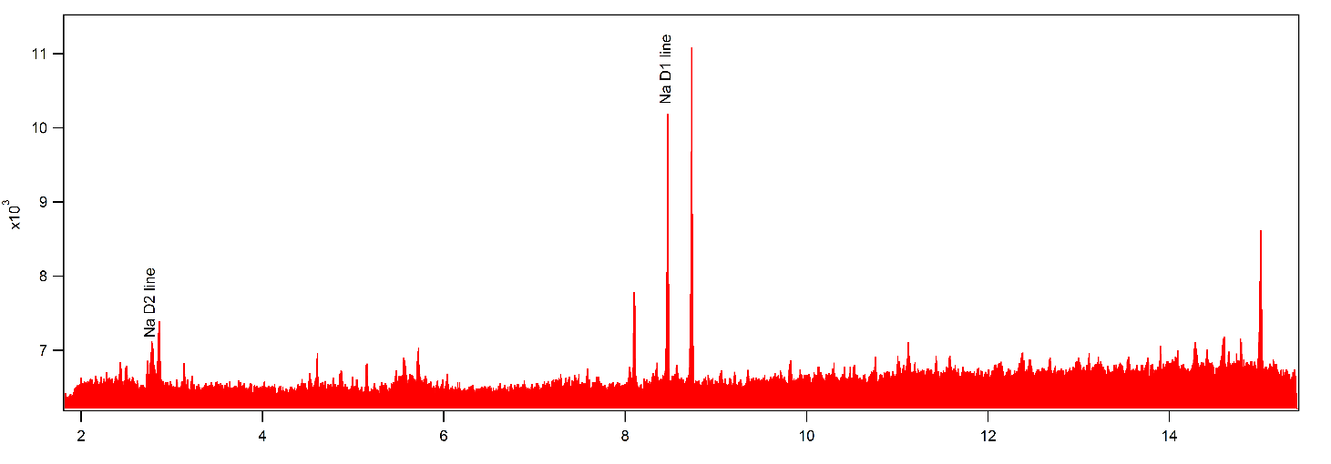

Figure 1: Yb spectra at the beam energy of 18 keV and CCD position of 1.25”. The wavelength range is from 1.82 nm to 15.42 nm.

Table 9:

EBIT Run Day 4 (06/16/17):

On Day 4, we continued optimizing the Ar signal on the vertical crystal spectrometer. But, we ran out of liquid He after an hour of data collection.

